Mr. Ngo - uit@gm.uit.edu.vn
Mr. Dinh - , uit@gm.uit.edu.vn

Prepared for
TechMarket Project
Version 1.0
SOFTWARE REQUIREMENTS SPECIFICATION
TechMarket

Revision and Sign Off Sheet
Change Record
Author | Version | Change reference | Date
Khai Ngo Quang | 0.1 | Initialize | 5/12/2023
Khai Ngo Quang | 0.2 | Add some use case description | 10/12/2023
Duong Dinh Quang | 0.3 | Update use case diagram, introduction and use case description | 20/12/2023
Khai Ngo Quang | 0.4 | Update use case diagram, business rules, message list | 08/1/2023
Duong Dinh Quang | 1.0 | Upload list and view description | 08/1/2023
Reviewers
Name | Version | Position | Date
Khai Ngo Quang | 0.1 | Application Owner | 6/12/2023
Khai Ngo Quang | 0.2 | Application Owner | 11/12/2023
Khai Ngo Quang | 0.3 | Application Owner | 21/12/2023
Khai Ngo Quang | 0.4 | Application Owner | 08/1/2023
Khai Ngo Quang | 1.0 | Application Owner | 08/1/2023

Table of Contents

1. Introduction 5
1.1. Purpose 5
1.2. Scope 5
1.3. Intended Audiences and Document Organization 5
2. Functional Requirements 7
2.1. Use Case Description 7
UC1: Sign In 7
Activities Flow 8
Business Rules 8
UC2: Sign Up 9
Activities Flow 10
Business Rules 10
UC3: Forgot Password 13
Activities Flow 14
Business Rules 15
UC4: Leave a feedback 18
Activities Flow 19
Business Rules 19
UC5: Create post 20
Activities Flow 20
Business Rules 21
UC6: Update post 22
Activities Flow 23
Business Rules 23
UC7: Delete post 25
Activities Flow 25
Business Rules 26
UC8: Guarantee payment 26
Activities Flow 27
Business Rules 27
UC9: Link sales wallet 28
Activities Flow 29
Business Rules 29
UC10: Use post push service 31
Activities Flow 32
Business Rules 33
UC11: Confirm sales order 35
Activities Flow 35
Business Rules 36
UC12: Place order 37
Activities Flow 38
Business Rules 38
UC13: Choose shipping address 41
Activities Flow 42
Business Rules 42
UC14: Pay 43
Activities Flow 44
Business Rules 44
UC15: Cancel order 48
Activities Flow 49
Business Rules 49
UC16: Confirm delivery of order 50
Activities Flow 50
Business Rules 51
UC17: Rate seller 51
Activities Flow 52
Business Rules 52
UC18: Chat with seller 54
Activities Flow 54
Business Rules 55
UC19: Report post 55
Activities Flow 56
Business Rules 56
UC20: Create category 57
Activities Flow 58
Business Rules 58
UC21: Update category 60
Activities Flow 60
Business Rules 61
UC22: Delete category 62
Activities Flow 62
Business Rules 62
UC23: Approve post 63
Activities Flow 64
Business Rules 64
UC24: Reject post 65
Activities Flow 66
Business Rules 66
UC25: Ban account 67
Activities Flow 67
Business Rules 68
UC26: Manage TechMarket bank account 71
Activities Flow 72
Business Rules 72
UC27: Update legal documents 73
Activities Flow 74
Business Rules 74
UC28: Update information for the help center 75
Activities Flow 76
Business Rules 76
UC29: Handle feedback from user 77
Activities Flow 77
Business Rules 78
2.2. List Description 78
2.3. View Description 78
3. Non-functional Requirements 78
3.1. User Access and Security 78
3.2. Performance Requirements 79
3.3. Implementation Requirements 80
4. Appendixes 80
Glossary 80
Messages 81
Issues List 83

Introduction

Purpose
This document serves as the comprehensive Software Requirements Specification (SRS) and Design Document for the TechMarket project. It encapsulates the detailed requirements and design considerations that will guide the development process. This document is an essential reference for developers, providing a roadmap for application functionality, task assignment, and deployment strategies.
The primary purpose of this document is to outline the software requirements for the TechMarket project and establish a clear design framework. It acts as a foundational guide for developers, project managers, and other stakeholders involved in the software development lifecycle. By detailing the functionalities and design principles, this document ensures a shared understanding of project goals and expectations.

Scope
The scope of this document encompasses both the functional and non-functional requirements of the TechMarket project. It defines how the applications under development will operate, outlining features, constraints, and interfaces. The scope extends to cover various aspects, including user interactions, system performance, security, and deployment considerations.

Intended Audiences and Document Organization
This comprehensive document outlines the roles and responsibilities of various teams involved in the TechMarket project. The project encompasses the development, documentation, and user acceptance testing (UAT) of the application. Each team plays a crucial role in ensuring the success of the project, and this document aims to provide a detailed overview of their responsibilities.
This document is intended for:
- Development team: The development team is at the forefront of transforming project requirements into functional, high-quality software. Their responsibilities extend from detailed design to implementation and testing at various levels.
- Documentation Team: The documentation team plays a critical role in creating user-friendly and informative documentation that accompanies the TechMarket application. Their work contributes to user understanding, efficient onboarding, and successful application usage.
- UAT team: The UAT team is responsible for validating the application's functionality and usability from an end-user perspective. Their role is crucial in ensuring that the application meets user expectations and requirements.

Below are main sections of the document:
- 1. Introduction: This section describes the general introduction of this document.
- 2. Functional Requirements: This section describes the functional requirements in detail.
- 3. Non-functional Requirements: This section describes the non-functional requirements of this application such as user access and security, interfaces, screens and performance.
- 4. Other Requirements: This section describes other requirements such as archive or security audit function.
- 5. Appendixes: This section describes other requirements for this application and other supporting information for this document.

Functional Requirements

Use Case Description

UC1: Sign In
Name | Sign In
Description | This use case describes the process by which a user logs into the system.
Actor | User
Trigger | - When the user clicks on the “Sign In” button.
Pre-condition | - The user is not logged in to the system.  - The user is in the sign in page (refer to “”Sign In Form” in “List description” file).
Post-condition | - The user is logged to the system.  - The user is redirected to the home page.

Activities Flow
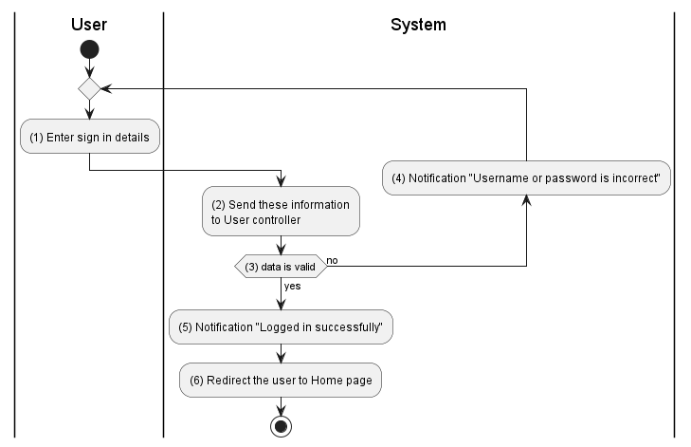

Business Rules
Activity | BR Code | Description
(3) | BR1 | Validate Rules:  - The system checks the items [username], [password].  - If any of them is null or blank the system will show an error message MSG 2.  - If [username] does not exist the system will show an error message MSG 22 else [user] = User Repository find by [username] (call findById() function)  - If hash([password]) != user.password then the system will show an error message MSG 22  else generate jwt from [user.id] and record this login session.
(4) | BR2 | Message Rules:  - The system shows the error message MSG 22.
(5) | BR3 | Message Rules:  - The system shows the success message MSG 23.
(6) | BR4 | Redirect Rules:  - The system redirects to the home page.

UC2: Sign Up

Name | Sign Up
Description | This use case describes the process by which a user creates a new account in the system
Actor | User
Trigger | - When the user clicks on the “Sign Up” button.
Pre-condition | - The user is on the sign up page (refer to “Sign Up Form” in “List description” file).
Post-condition | - New account has been created in the ‘INACTIVE’ state.  - The user will be redirected to the home page.  - The user will be asked to verify through email.

Activities Flow
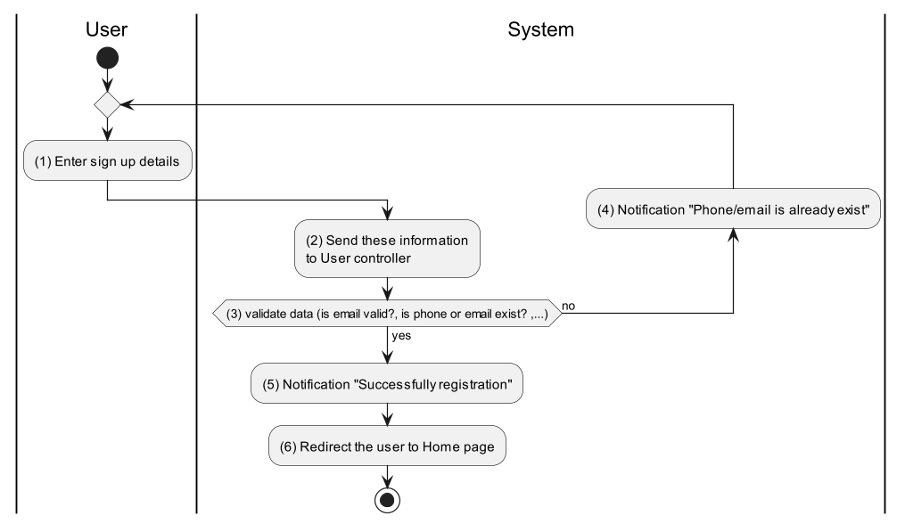

Business Rules
Activity | BR Code | Description
(3) | BR5 | Validate Rules:  - The system checks the items [username], [password], [phoneNumber], [email].  - If any entries are empty, the system shows an error message MSG 2.  - If [username.length] < 8 then the system shows an error message MSG 24.  - If pattern.compile(“"^(?=.*[0-9])(?=.*[a-zA-Z])(?=.*[@#$%^&+=!])(?=\\S+$).{8,}$"”).notMatch([password]) then the system shows an error message MSG 25.  - If pattern.compile(‘^(84|0[3|5|7|8|9])+([0-9]{8})$’).notMatch([phoneNumber]) or then returns 400-BAD_REQUEST error with error message MSG 30  - If pattern.compile(‘^[a-zA-Z0-9._%+-]+@[a-zA-Z0-9.-]+\.[a-zA-Z]{2,}$’).notMatch([email]) then returns 400-BAD_REQUEST error with error message MSG31.  - If [phoneNumber] exists in the system then the system shows an error message MSG 26.  - If [email] exists in the system then the system shows an error message MSG 27.  - [user] = User Repository save new user with all data (call save() function)  - [user.status] = ‘INACTIVE’  - The system will show a success message MSG 28.  - Send verify email as Email Templates below,  - Email Templates:  - Send mail to user register account as the template below:  From techmarket@gmail.com  To [email]  Cc N/A  Subject Get [Subject] of “Email Template” item of which [Keyword] = “Sign Up”  Body Get [Body] of “Email Template” item of which [Keyword] = “Sign Up”  - Following is sample email content:  Subject "Verify Registration Tech Market Account"  Body [Body] = “Hello,” [Body] = [Body] + 2 new lines [Body] = [Body] + “Follow this link to verify your email address to finish your registration step.” [Body] = [Body] + 2 new lines [Body] = [Body] + <<Link to verify email>> [Body] = [Body] + "If you didn’t ask to verify this address, you can ignore this email." [Body] = [Body] + 2 new lines [Body] = [Body] + "Thanks." [Body] = [Body] + 2 new lines [Body] = [Body] + "The Tech Market team"
(5) | BR6 | Message Rules:  - The system shows success message MSG 28
(4) | BR7 | Message Rules:  - The system shows success message MSG 29
(6) | BR8 | Redirect Rules:  - The system redirects to the home page.

UC3: Forgot Password
Name | Forgot Password
Description | This use case describes the process by which users reset their password when they forgot it.
Actor | User
Trigger | - When the user clicks on the “Forgot password” button.
Pre-condition | - The user is not logged in to the system.  - The user is in the sign in page.
Post-condition | - Password has been changed.  - The user is redirected to the home page.

Activities Flow
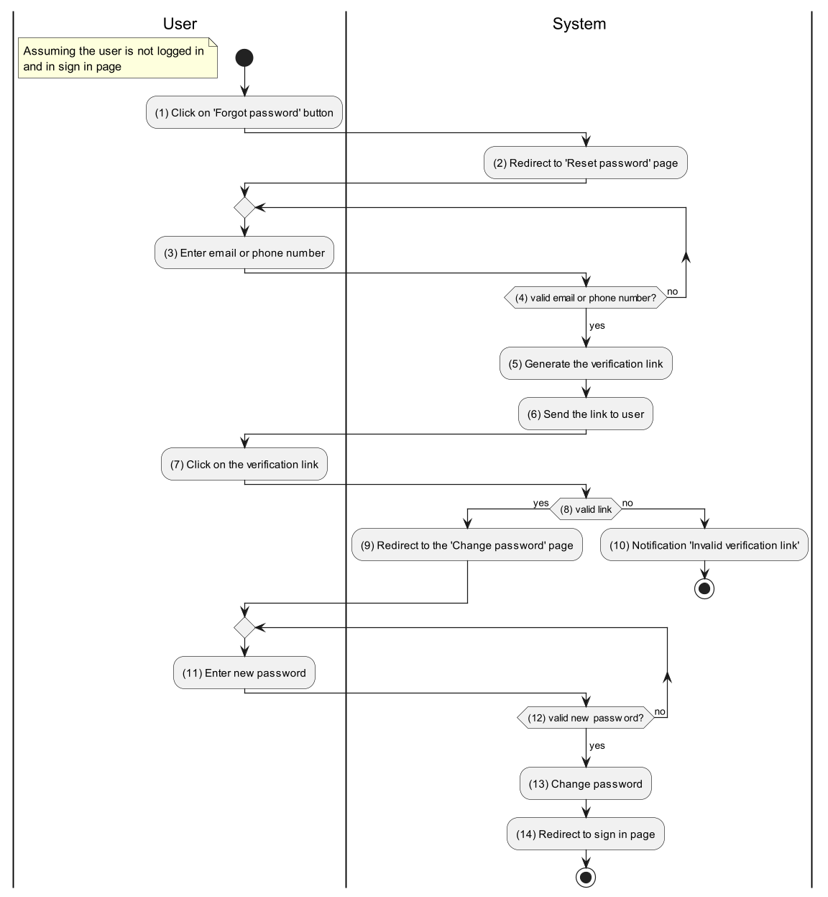

Business Rules
Activity | BR Code | Description
(2) | BR9 | Redirect Rules:  - The system redirects to the forgot password page (refer to “”Forgot Password Form” in “List description” file).
(4) | BR10 | Validate Rules:  - The system will receive [email] or [phoneNumber].  - If [email] or [phoneNumber] is null or blank, then return 400-BAD_REQUEST error with error message MSG2.  - If pattern.compile(‘^(84|0[3|5|7|8|9])+([0-9]{8})$’).notMatch([phoneNumber]) or then returns 400-BAD_REQUEST error with error message MSG 30  - If pattern.compile(‘^[a-zA-Z0-9._%+-]+@[a-zA-Z0-9.-]+\.[a-zA-Z]{2,}$’).notMatch([email]) then returns 400-BAD_REQUEST error with error message MSG31.  - [user] = User Repository findByPhoneOrEmail([phoneNumber], [email]) (call findByPhoneOrEmail() function)  - If [user] == null then returns 400-BAD_REQUEST error with error message MSG32.
(5) | BR11 | Generate Link Rules:  - [link.expired_in] = Date.now().plus(10, MINUTES).
(6) | BR12 | Send Link Rules:  Email Templates:  ❖ Send mail to user change password or message through zalo as the template below:  From techmarket@gmail.com  To [user.email]  Cc N/A  Subject Get [Subject] of “Email Template” item of which [Keyword] = “Forgot Password”  Body Get [Body] of “Email Template” item of which [Keyword] = “Forgot Password”  Following is sample email content:  Subject "Reset Password"  Body [Body] = “Hello,” [Body] = [Body] + 2 new lines [Body] = [Body] + “You have requested to reset the password of your TECH MARKET account.” [Body] = [Body] + 2 new lines [Body] = [Body] + "Please click the link to change your password: " [Body] = [Body] + 2 new lines [Body] = [Body] + [link] [Body] = [Body] + 2 new lines [Body] = [Body] + "If you didn’t ask to reset your password, you can ignore this email." [Body] = [Body] + "Thanks." [Body] = [Body] + 2 new lines [Body] = [Body] + "The TechMarket team"
(8) | BR13 | Validate Rules:  - If [link.expired_in].isAfter(Date,now()) then the system redirects to the Change password page.  else the system will show an error message MSG 33.
(12) | BR14 | Validate Rules:  - The system will receive [password].  - If [password] is null or blank, then return 400-BAD_REQUEST error with error message MSG2.  - If pattern.compile(“"^(?=.*[0-9])(?=.*[a-zA-Z])(?=.*[@#$%^&+=!])(?=\\S+$).{8,}$"”).notMatch([password]) then the system shows an error message MSG 25.  - If hash([password]) == [user.password] then the system shows an error message MSG 34.  else [user.password] = hash([password])
(14) | BR15 | Redirect rules:  - The system redirects to the sign in page.

UC4: Leave a feedback
Name | Leave a feedback
Description | This use case describes how users can leave feedback.
Actor | User
Trigger | - When the admin clicks on the “Feedback” button.
Pre-condition | - The user are access to the TechMarket website
Post-condition | - The feedback are created

Activities Flow
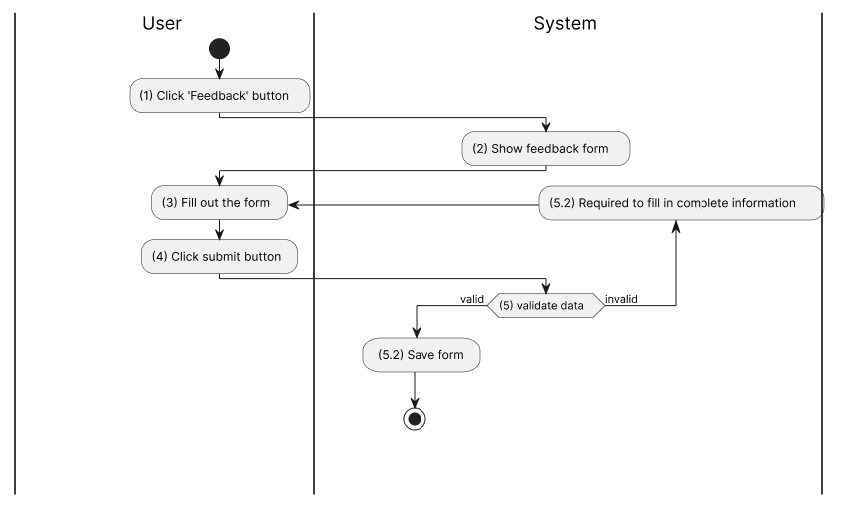

Business Rules
Activity | BR Code | Description
(2) | BR16 | Feedback Form Rules:  - The system loads the “Leave a feedback” page (refer to “”Leave Feedback Form” in “List description” file).  - The form includes the following information fields:  - [feedback_category] Feedback category:  - Faulty feature  - Request new feature  - Other  - [comment]  - [proof] ( image/video )
(5) | BR17 | Creating Rules:  When the user clicks on “Save”, the system will prompt a confirmation message (Refer to MSG 1). If user chooses Cancel, the system does nothing; else, the system will save inputted information and update the item as the following:  - The system checks the items [feedback_category], [comment]  - If any entries are empty, the system shows an error message MSG 2.  - The feedback will be saved with the items: [feedback_category], [comment], [proof] (can be null ), [status] = PENDING

UC5: Create post
Name | Create post
Description | This use case allows Sellers to create a post that contains their product information.
Actor | User
Trigger | - When the user clicks on the “Create post” button.
Pre-condition | - The user is logged in to the system.  - The user is in the create post page.
Post-condition | - The posts have been created.

Activities Flow
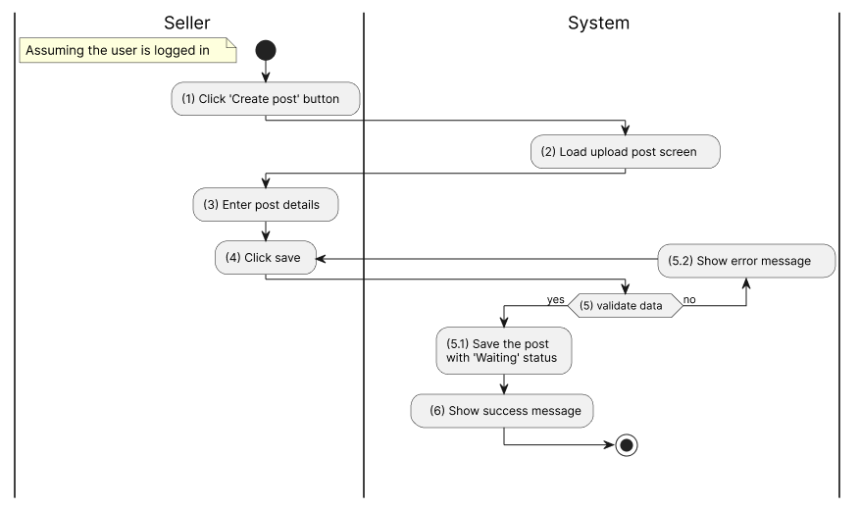
Figure 1: Activities Flow

Business Rules
Activity | BR Code | Description
(2) | BR18 | Loading Screen Rules:  - The system loads the “Create post” screen (refer to “”Create Post Form” in “List description” file).
(5) | BR19 | Creating Rules:  When the user clicks on “Save”, the system will prompt a confirmation message (Refer to MSG 1). If user chooses Cancel, the system does nothing; else, the system will save inputted information and update the item as the following:  - The client concat values from [province], [district] and [ward] to [area].  - The system checks the items [images], [product], [price], [title], [description], [area].  - If any entries are empty, the system shows an error message MSG 2.  - If size of any in [images] > 8.MB then system shows error message MSG 11  - If [product] does not exist then the system shows error message MSG 12.  - If [price] < 0 then the system shows error message MSG 13.  - If [description].length < 50 then the system shows error message MSG 14.  - [user] = <<current user id retrieved from jwt>>  - [createdDate] = <<current date time>>  - [status] = ‘CREATED’. When a post is in this state, no one except the owner and Administrator can see and interact with it
(6) | BR20 | Message Rules:  - The system shows success message MSG 3

UC6: Update post
Name | Update post
Description | This use case describes how user can update a post
Actor | User
Trigger | - When the user clicks on the “Save” button.
Pre-condition | - The user is logged in to the system.  - The user has created this post.  - The user in the edit post page.
Post-condition | - The posts have been updated.  - The post is in ‘Waiting’ status

Activities Flow
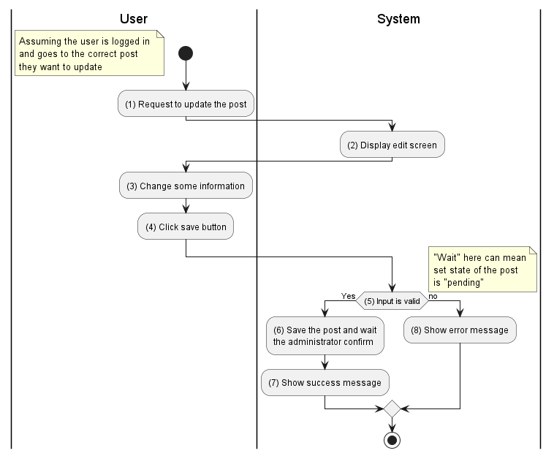

Business Rules
Activity | BR Code | Description
(2) | BR21 | Loading Screen Rules:  - The system loads the “Update post” screen (refer to “”Update Post Form” in “List description” file).
(5) | BR22 | Validate Rules:  When the user clicks on “Save”, the system will prompt a confirmation message (Refer to MSG 1). If user chooses Cancel, the system does nothing; else, the system will save inputted information and update the item as the following:  - The system checks the items [images], [product], [price], [title], [description], [area].  - If any entries are empty, the system shows an error message MSG 2.  - If size of any in [images] > 8.MB then system shows error message MSG 11  - If [product] does not exist then the system shows error message MSG 12.  - If [price] < 0 then the system shows error message MSG 13.  - If [description].length < 50 then the system shows error message MSG 14.  - [user] = <<current user id retrieved from jwt>>  - [updatedDate] = <<current date time>>  - [status] = ‘PENDING’. When a post is in this state, no one except the owner and Administrator can see and interact with it
(7) | BR23 | Message Rules  - The system shows success message MSG 16
(8) | BR24 | Message Rules:  - The system shows success message MSG 17

UC7: Delete post

Name | Delete post
Description | This use case describes how a user can delete a post.
Actor | User
Trigger | - When the user clicks on the “Delete post” button.
Pre-condition | - The user is logged in to the system.  - The user has created this post.  - The user in the edit post page.
Post-condition | - The posts have been deleted.

Activities Flow
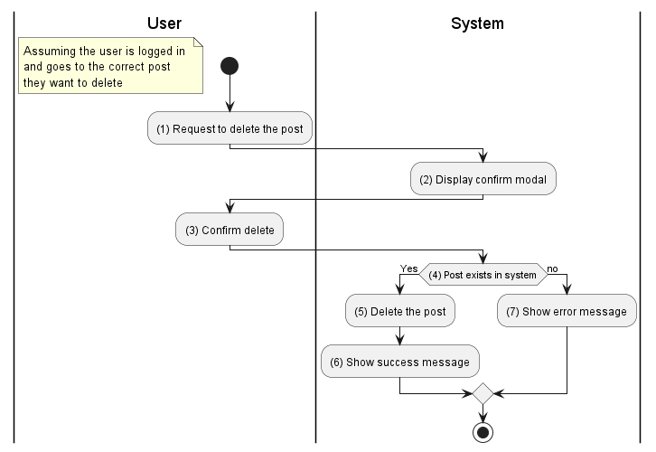

Business Rules
Activity | BR Code | Description
(2) | BR25 | Loading Modal Rules:  - The system loads the “Delete confirmation” modal.
(4) | BR26 | Checking Rules:  - If [postId] does not exist, the system shows an error message MSG 18 else [post] = Post Repository find by [postId] (call findById() function)
(5) | BR27 | Delete Rules:  - If [post.order] == null then Post Repository delete by [post.id] (call deleteById() function) else the system show error message MSG 19
(6) | BR28 | Message Rules:  - The system shows success message MSG 20
(7) | BR29 | Message Rules:  - The system shows error message MSG 21

UC8: Guarantee payment
Name | Guarantee payment
Description | This use case describes how users can use guaranteed payment functionality for their posts.
Actor | Seller
Trigger | - When the Seller clicks the button.
Pre-condition | - The Seller logs into the system.
Post-condition | - The post is updated to the ‘Guarantee’ plan.

Activities Flow
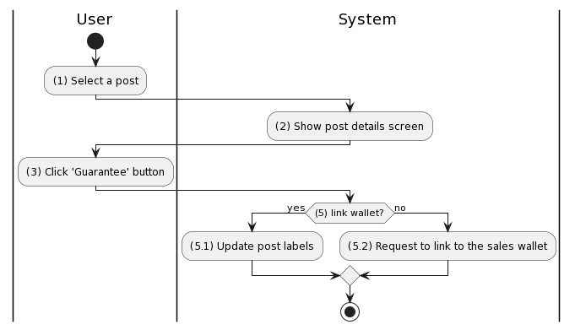

Business Rules
Activity | BR Code | Description
(2) | BR30 | Loading Screen Rules:  - The system loads the post details screen (refer to “Seller/Post Details” in “List description” file).
(5) | BR31 | Check Sales Wallet Rules:  - If ([user.sales_wallet] != null) then the system return response with status code 200 and show confirm message MSG 1  else the system return response with status code 400
(5.1) | BR32 | Update post rules:  - [post.label] = ‘GUARANTEE’  - The system shows message MSG 43
(5.2) | BR33 | Request link sales wallet Rules:  - The system shows message MSG 44

UC9: Link sales wallet
Name | Link sales wallet
Description | This use case describes how a user can link to their merchant wallet.
Actor | Seller
Trigger | - When the Seller clicks the “Link sales wallet” button.
Pre-condition | - The Seller logs into the system.
Post-condition | - This Seller ‘s sales wallet is activated.

Activities Flow
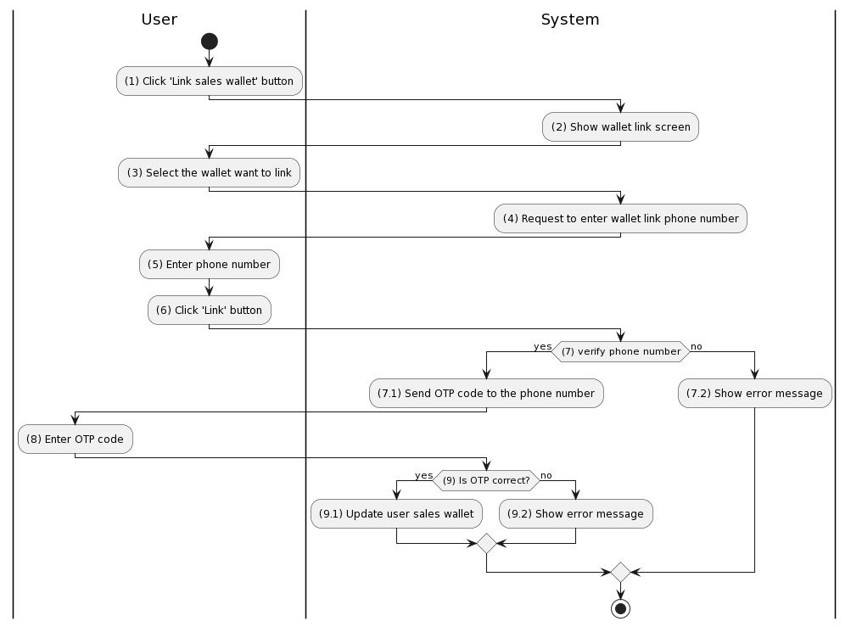

Business Rules
Activity | BR Code | Description
(2) | BR34 | Loading Screen Rules:  - The system loads the “Wallet link” screen (refer to “Wallet Link” in “List description” file).
(3) | BR35 | Select wallet Rules:  - The user chooses one of the following wallets:  - Momo  - Paypoo
(7) | BR36 | Phone number verification rules:  - The system use the abstract API phone validator to verify phone numbers with default country code is ‘VN’  - If [phone] is valid then the abstract API return response contains [valid] = true  else the abstract API return response contains [valid] = false
(7.1) | BR37 | Sending OTP Code Rules:  - The system generate an OTP code to verify user own phone number with [expire] = 60000 ( mean 1 minutes )
(7.2) | BR38 | Message Rules:  - The system show message MSG 45
(9) | BR39 | Checking OTP Rules:  - If [OTP_code] is match then the system return response with status code 200  - else the system return response with status code 400
(9.1) | BR40 | Update sales wallet rules:  - If response.status_code == 200 then  [user.sales_wallet] = {  “vendor” : <<selected wallet>> (ex: “Momo”),  “phone” : <<encrypted phone number>>  }
(9.2) | BR41 | Message rules:  - The system show message MSG 46

UC10: Use post push service

Name | Use post push service
Description | This use case describes how a user can use the post push service, increase product sales.
Actor | Seller
Trigger | - When the Seller clicks the 'Push to top’ button.
Pre-condition | - The Seller logs into the system.  - The post has been created, approved by Admin and not hidden .
Post-condition | - The post is pushed to the top of the page.

Activities Flow
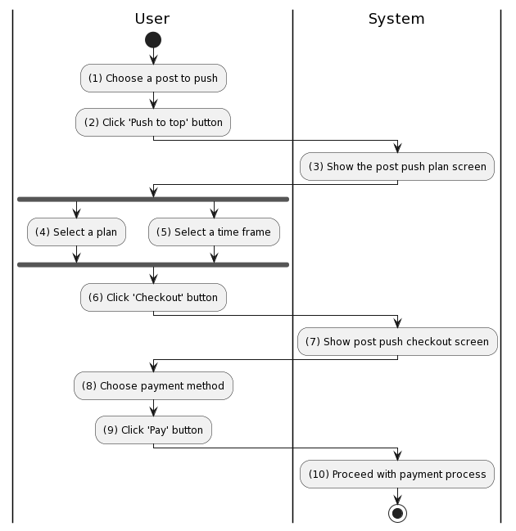

Business Rules
Activity | BR Code | Description
(3) | BR42 | Loading Screen Rules:  - The system loads the “Post push plan” screen” (refer to “Post Push Plan” in “List description” file).
(4) | BR43 | Post push plan Rules:  - The system shows service plan list comes with price (for each push):  - Now  - 3 days  - 7 days
(5) | BR44 | Post push time frame Rules:  - The system shows service time frame list:  - 8h00 - 9h00  - 9h00 - 10h00  - 10h00 - 11h00  - 13h00 - 14h00  - 14h00 - 15h00  - 15h00 - 16h00  - 16h00 - 17h00  - 18h00 - 19h00  - 19h00 - 20h00  - 20h00 - 21h00
(7) | BR45 | Loading Screen Rules:  - The system loads the “Post push checkout” screen (refer to “Post Push Checkout” in “List description” file).
(8) | BR46 | Select payment method Rules:  - The user selects the following available payment methods:  - Cash on delivery (COD)  - Payment via visa/mastercard  - Payment via Momo e-wallet  - Payment via PayPoo  - Payment via ZaloPay  - Payment via VNPAY  - Payment via Paypal payment gateway  - Payment via internet banking . A few affiliate banks are available like: ABBank, ACB,AgriBank, Bac A Bank, Bảo Việt Bank, BIDV, Đông á bank, Eximbank, GPBank, HDBank, Liên Việt Bank, MB Bank, Nam Á Bank, NCB, OCB, OCEAN BANK, Sacombank, SCB, SeaBank, SHB, TechcomBank, TPBank, VIB, VietABank, Vietcombank, Vietinbank, VPBank
(10) | BR47 | Payment process rules:  When the user clicks on “Pay”, the system will prompt a confirmation message (Refer to MSG 1). If user chooses Cancel, the system does nothing; else, the system will save inputted information and update the item as the following:  - The system checks the items [post_id], [Rules], [Time frames].  - If any entries are empty, the system shows an error message MSG 2.  - [Push Plan.post] = Post repository find by id [post_id] (call findById() function)  - [Push Plan.rules] = [Rules]  - [Push Plan.timeFrames] = [Time frames]  - Save [Push Plan] to database (call save() function)  - The system will process payment like UC14

UC11: Confirm sales order

Name | Confirm sales order
Description | This use case describes how sellers can confirm the order of buyers.
Actor | Seller
Trigger | - When the user clicks on the “Confirm” button.
Pre-condition | - The buyer is logged in to the system.  - The user has placed the order successfully.
Post-condition | - The order status has been changed to ’CONFIRMED’

Activities Flow
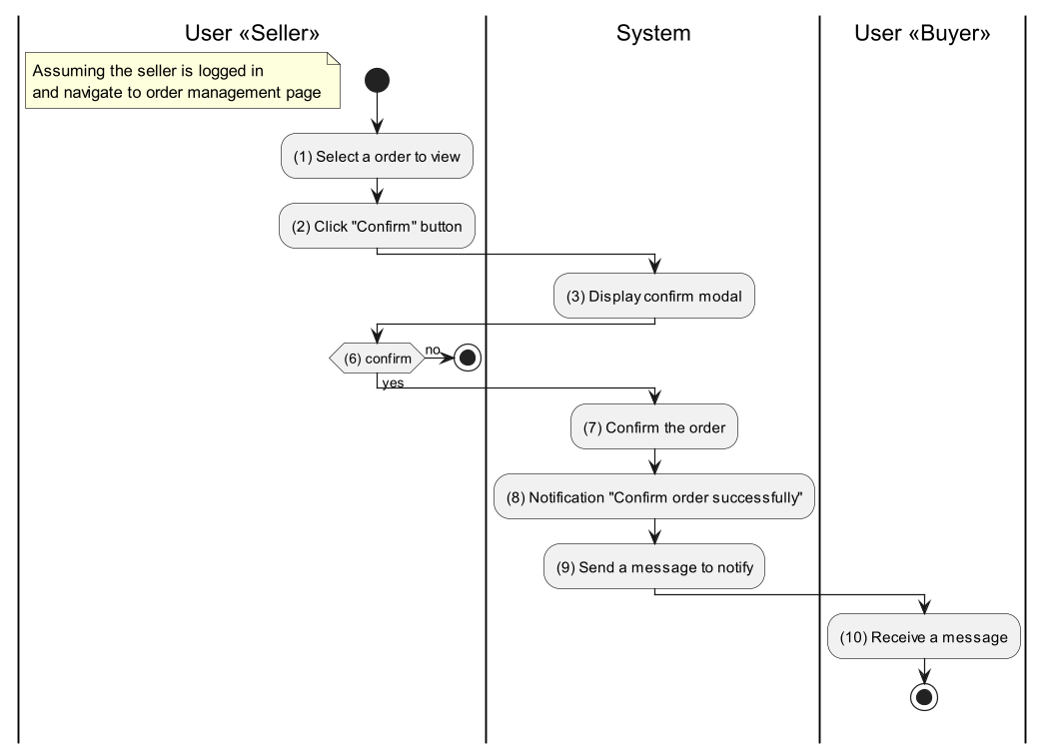

Business Rules
Activity | BR Code | Description
(1) | BR48 | Loading Screen Rules:  - The system loads the “Order Details” screen (refer to “Seller/Order Details” in the “List description” file).
(7) | BR49 | Confirm rules:  - The system extract the [orderId] from the request  - If [orderId] == null then the system returns error response with status code 400 BAD_REQUEST  - If [order] = Order repository find by id ([orderId]) == null then the system returns error response with status code 400 BAD_REQUEST  - If [order.status] != ‘CREATED’ then the systems returns error response with status code 400 BAD_REQUEST  - [order.status] = ‘CONFIRMED’
(8) | BR50 | Message rules:  - The system shows message MSG 40.
(9) | BR51 | Send message rules:  - The system sends a notification to the buyer’s dialog box according to the following template:  - [Seller name] + ' has successfully confirmed the order with id' + [Order id].

UC12: Place order

Name | Place order
Description | This use case allows the Buyer to place orders.
Actor | Buyer
Trigger | - When the user clicks on the “Buy now” button in the post details screen.  - Otherwise, user clicks on “Buy” button in cart screen
Pre-condition | - The user is logged in to the system.
Post-condition | - The order has been created.  - In case the user chooses to pay online, the payment will be transferred to TechMarket's account for safekeeping.

Activities Flow
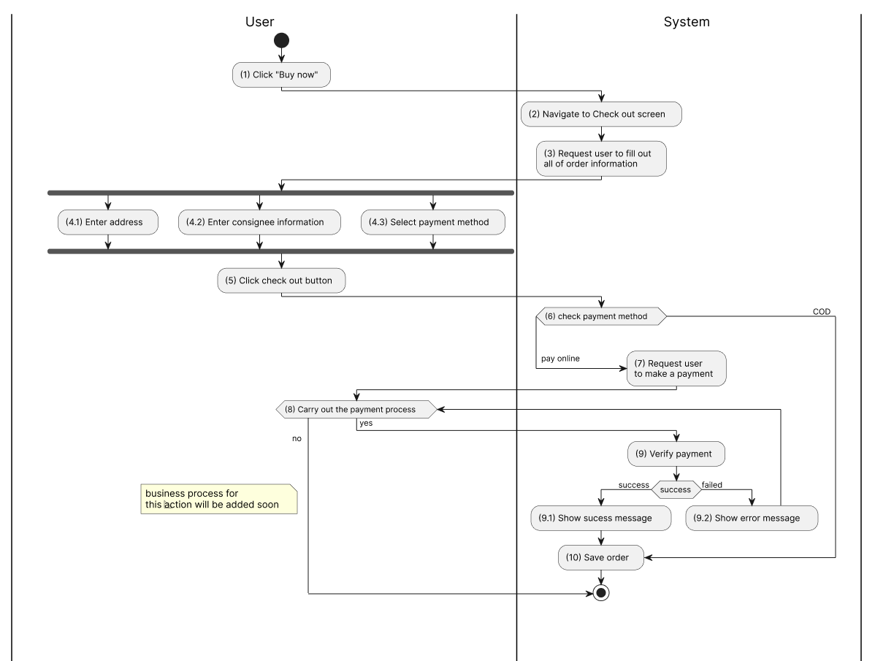

Business Rules
Activity | BR Code | Description
(2) | BR52 | Loading Screen Rules:  - The system loads the “Check out” screen (refer to “Checkout” in the “List description” file).
(4.1) | BR53 | Address enter Rules:  - The user selects an existing address previously saved in the account or enters a new address.  - When the user clicks on “Save”, the system will prompt a confirmation message (Refer to MSG 1). If user chooses Cancel, the system does nothing; else, the system will save inputted information and update the item as the following:
(4.2) | BR54 | Consignee information enter Rules:  - The user enters consignee information, including [Name], [Phone number].  - Additionally, users can confirm information available in the account (if any)  - When the user clicks on “Save”, the system will prompt a confirmation message (Refer to MSG 1). If the user chooses Cancel, the system does nothing; else, the system will save inputted information and update the item.
(4.3) | BR55 | Select payment method Rules:  - The user selects the following available payment methods:  - Cash on delivery (COD)  - Payment via visa/mastercard  - Payment via Momo e-wallet  - Payment via PayPoo  - Payment via ZaloPay  - Payment via VNPAY  - Payment via Paypal payment gateway  - Payment via internet banking . A few affiliate banks are available like: ABBank, ACB,AgriBank, Bac A Bank, Bảo Việt Bank, BIDV, Đông á bank, Eximbank, GPBank, HDBank, Liên Việt Bank, MB Bank, Nam Á Bank, NCB, OCB, OCEAN BANK, Sacombank, SCB, SeaBank, SHB, TechcomBank, TPBank, VIB, VietABank, Vietcombank, Vietinbank, VPBank
(6) | BR56 | Check payment method rules:  - The system checks the payment method the user has chosen.  - If it is an online payment, the user needs to complete the payment according to the regulations states in BR8
(8) | BR57 | Make payment rules  - Switch ([paymentMethod])  - case (‘visa/mastercard’) : the following information must be filled in: [card number], [cardholder name], [card opening date] and [CVV number]  - case (‘Paypal’) : they need to enter their account information correctly  - case (‘Momo e-wallet’ || ‘ZaloPay’ || ‘VNPAY’ || ‘PayPoo’ ): they need to do:  - For TechMarket web: Scan the QR code with the Momo/Zalo/VNPAY application on their phone to pay  - For TechMarket application on phone: Log in to Momo/Zalo/VNPAY on phone to make payment. The system must navigate to the Momo application and manually create an invoice with the following information: [Order code], [Order value]  - case (‘internet banking’): they need to enter complete information as required by each bank.
(9.1) | BR58 | Message rules:  - The system shows message MSG 4
(9.2) | BR59 | Message rules:  - The system shows message MSG 5
(10) | BR60 | Saving rules:  - In online payment case, the payment will be transferred to TechMarket's account for safekeeping  - The system creates an order as the Order template below.
Order template
- [orderId] = <<automatic generated>>
- [orderPrice] = <<total of price of products, shipping fee>>
- [userId] = <<current user’s id>>
- [deliveryAddress] = <<address that user entered>>
- [paymentMethod] = <<method that user chosen>>
- if ([paymentMethod] = ‘COD’) then
[paymentStatus] = ‘unpaid’
else [paymentStatus] = ‘paid’
- [shipmentStatus] = ‘order successful’
- [orderStatus] = ‘wait for confirmation’
- [productList[]] = <<list of product>>

UC13: Choose shipping address

Name | Choose shipping address
Description | This use case describes how a user can select an existing address or create a new one.
Actor | Buyer
Trigger | - When the Buyer clicks on the “Choose address” button.
Pre-condition | - The Buyer is logged in to the system.  - The Buyer is on the place order page (refer to “Checkout” in the “List description” file).
Post-condition | - The new address is saved.

Activities Flow
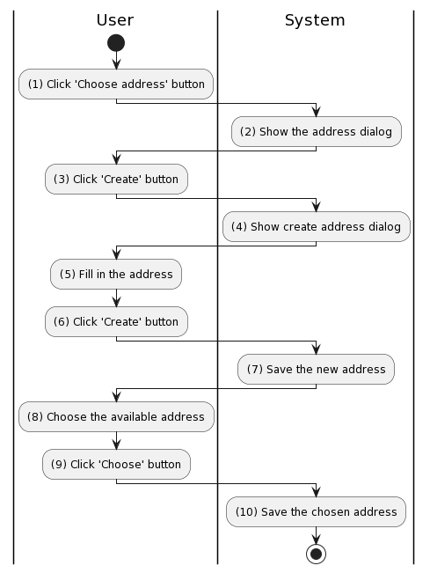

Business Rules
Activity | BR Code | Description
(2) | BR61 | Loading Dialog Rules:  - The system shows the address dialog
(4) | BR62 | Loading Dialog Rules:  - The system shows create address dialog
(5) | BR63 | Fill In Address Rules:  - The system displays the steps to fill in the address:  [province_city] -> [district] -> [ward] -> [details]
(7) | BR64 | Creating Rules:  When the user clicks the “Create” button, the system will prompt a confirmation message (Refer to MSG 1). If user chooses Cancel, the system does nothing; else, the system will save inputted information and update the item as the following:  - The system checks the items [province_city], [district], [ward], [details].  - If any entries are empty, the system shows an error message MSG 2.  - [address.user] = <<current user id retrieved from jwt>>  - [address.createAt] = <<current date time>>
(10) | BR65 | Saving Rules:  - The currently created order is updated with:  - [order.address] = <<chosen address>>

UC14: Pay

Name | Pay
Description | This use case describes how users can pay for orders through the payment gateway.
Actor | Buyer
Trigger | - When the user clicks on the “Pay now” button .
Pre-condition | - The user is logged in to the system.  - The user is on the checkout page (refer to “Checkout” in the “List description” file).  - The user has chosen Pay via payment gateway.
Post-condition | - The payment has been created for order.  - Money has been transferred to the system.

Activities Flow
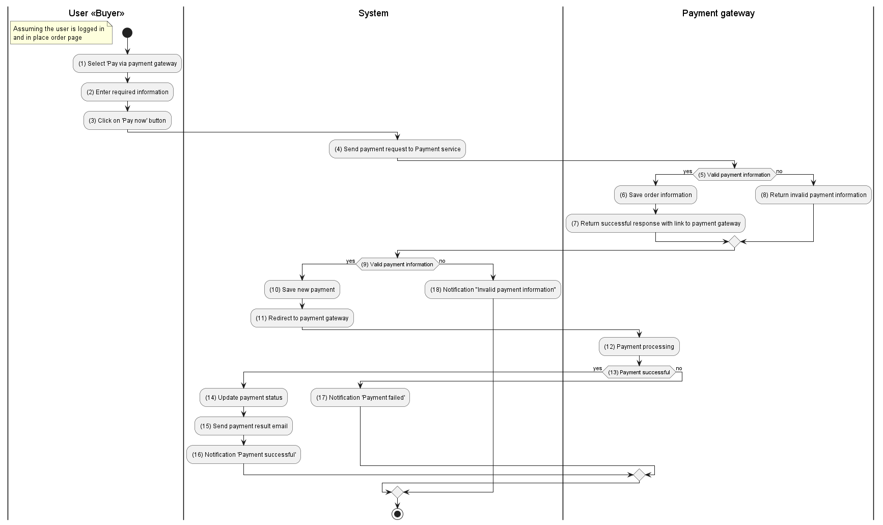

Business Rules
Activity | BR Code | Description
(4) | BR66 | Creating request rules:  - The system extracts order information from the request.  - [order] = request.body.order  - Create [paymentRequest]  - [paymentRequest.data] = [oder] to xml  - [paymentRequest.checksum] = SHA512([paymentRequest.data] + [private-key])  - [paymentRequest.method] = request.body.method  - paymentClient.send([paymentRequest])
(5) | BR67 | Validate Rules:  - The system extracts items from [paymentRequest]: [data], [checksum] and [method]  - If any entries are empty, the system shows an error message MSG 2.  - If [checksum] is not valid or [method] is unsupported then the system returns an error response.  Else the system saves order information and creates a link for paying this order.
(9) | BR68 | Validate Rules:  - The system extracts the response from payment service  - If [response.status] == 200 then  [order] = Order repository find by id [response.order.id]  [payment] = Payment repository creates new payment.  [payment.order] = [order]  [payment.createdDate] = Date.now()  [payment.provider] = corresponding provider  [payment.method] = [response.method]  [payment.status] = ‘PENDING’  return success response with [payment] and payment gateway link [response.link]  else the system returns an error message MSG37.
(11) | BR69 | Redirect Rules:  - The system redirects the user to the link that has been received from the payment service.
(12) | BR70 | Payment processing rules:  - The system updates the corresponding payment.  - [payment.status] = ‘PROCESSING’
(14) | BR71 | Update payment success rules  - The system updates the corresponding payment.  - [payment.status] = ‘COMPLETED’
(15) | BR72 | Sending email rules:  - Email Templates:  - Send mail to user after successful order payment::  From techmarket@gmail.com  To [email]  Cc N/A  Subject Get [Subject] of “Email Template” item of which [Keyword] = “Order Payment Success”  Body Get [Body] of “Email Template” item of which [Keyword] = “Order Payment Success”  - Following is a sample email content:  Subject "Order Payment Confirmation - Tech Market"  Body [Body] = “Hello,” [Body] = [Body] + 2 new lines [Body] = [Body] + “Thank you for your purchase! Your order payment has been successfully processed.” [Body] = [Body] + 2 new lines [Body] = [Body] + “- Order Number: [Order Number]” [Body] = [Body] + “- Payment Amount: [Payment Amount]” [Body] = [Body] + “- Payment Method: [Payment Method]” [Body] = [Body] + “Your items will be shipped shortly. You can track your order using the provided tracking details.” [Body] = [Body] + "If you have any questions or concerns, please feel free to contact our customer support." [Body] = [Body] + 2 new lines [Body] = [Body] + "Thanks for shopping with Tech Market!" [Body] = [Body] + 2 new lines [Body] = [Body] + "Best regards," [Body] = [Body] + 2 new lines [Body] = [Body] + "The Tech Market team"
(16) | BR73 | Message rules:  - The system shows message MSG 38
(17) | BR74 | Message rules:  - The system shows message MSG 39

UC15: Cancel order

Name | Cancel order
Description | This use case describes how a user can cancel an order
Actor | Buyer
Trigger | - When the Buyer clicks the cancel button.
Pre-condition | - The Buyer is logged in to the system.  - The user is on the order details page (refer to “Buyer/Order Details” in the “List description” file).  - The order has been created and is in CREATED status
Post-condition | - The order was cancelled successfully.

Activities Flow
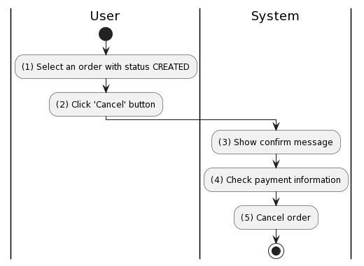

Business Rules
Activity | BR Code | Description
(3) | BR75 | Message Rules:  - The system will prompt a confirmation message (Refer to MSG 1). If user chooses Cancel, the system does nothing;
(4) | BR76 | Check payment information Rules:  - The system checks order payment information and is ready to refund within 7 days.  - When the refund is successful, [order.payment_status] = REFUND
(5) | BR77 | Cancelling Rules:  - [order.status] = CANCEL

UC16: Confirm delivery of order

Name | Confirm delivery of order
Description | This use case allows Buyer to confirm delivery of order.
Actor | Buyer
Trigger | - When the user clicks on the “Received” button.
Pre-condition | - The user is logged in to the system.  - The user is on the order details page (refer to “Buyer/Order Details” in the “List description” file).  - The order has been successfully delivered by the shipping unit.
Post-condition | - The money is transferred to the seller's account.

Activities Flow
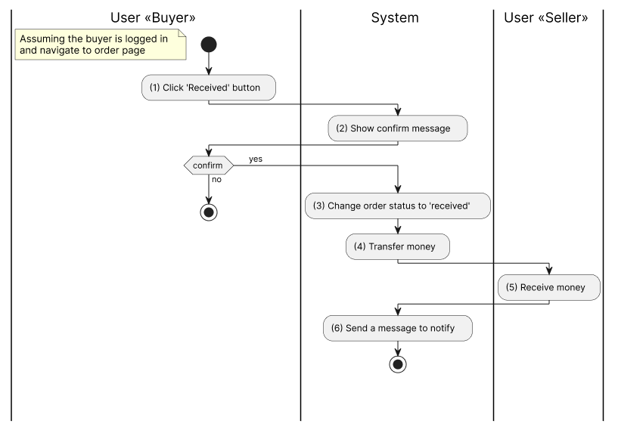

Business Rules
Activity | BR Code | Description
(2) | BR78 | Message rules:  - The system shows message MSG 6
(4) | BR79 | Money transfer rules:  - Upon successful delivery, payment funds previously kept securely in TechMarket's account will be transferred to the seller's account.
(6) | BR80 | Notification rules:  - The system sends a notification to the seller's dialog box according to the following template:  - [Buyer name] + ' has successfully confirmed receipt of the order with code ' + [Order code].

UC17: Rate seller

Name | Rate seller
Description | This use case describes how buyer can rate the seller after receiving order
Actor | Buyer
Trigger | - When the user clicks on the “Rate” button.
Pre-condition | - The user is logged in to the system.  - The order has been successfully confirmed to be shipped by the shipping unit.
Post-condition | - Seller’s rating has been saved.

Activities Flow
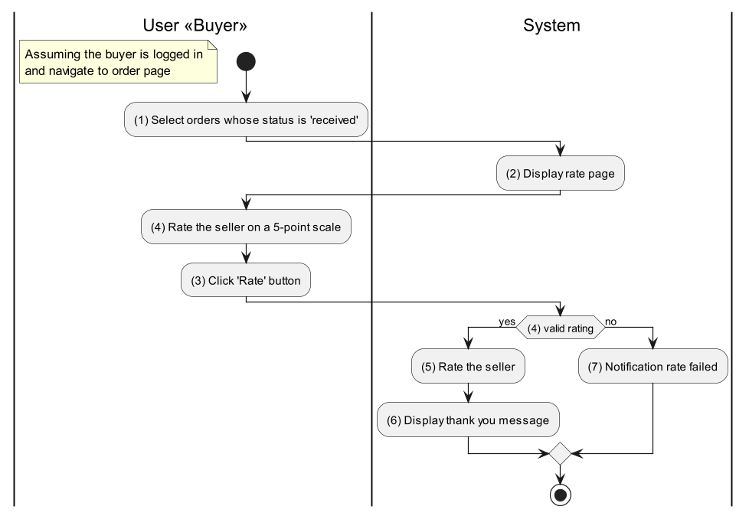

Business Rules
Activity | BR Code | Description
(2) | BR81 | Loading screen rules:  - The system loads the Rate page (refer to “Rate Seller Form” in the “List description” file).
(4) | BR82 | Validate rules:  - The system extracts the rating data from request: [buyerId], [sellerId], [postId], [comment] and [rating]  - If any of them is null or empty then the system returns error message MSG 2.  - [buyer] = User repository find by id [buyerId] (call userRepository.findById() function)  - [seller] = User repository find by id [sellerId] (call userRepository.findById() function)  - [post] = Post repository find by id [postId] (call postRepository.findById() function)  - If [buyer] == null then the system returns error response with status code 400 BAD_REQUEST  - If [seller] == null then the system returns error response with status code 400 BAD_REQUEST  - If [post] == null then the system returns error response with status code 400 BAD_REQUEST
(5) | BR83 | Rate rules:  - [rate] = Rating repository create new.  - [rate.buyer] = [buyer]  - [rate.seller] = [seller]  - [rate.buyer] = [buyer]  - [rate.rating] = [rating]  - [rate.comment] = [comment]
(6) | BR84 | Message rules:  - The system shows message MSG 42.
(7) | BR85 | Message rules:  - The system shows message MSG 41.

UC18: Chat with seller
Name | Chat with seller
Description | This use case describes how users can view post and product details.
Actor | User
Trigger | - When the user clicks on the “Chat with seller” button.
Pre-condition | - The user is on the post details page (refer to “User/Post Details” in the “List description” file).
Post-condition | - The user is redirected to the Chat page.

Activities Flow
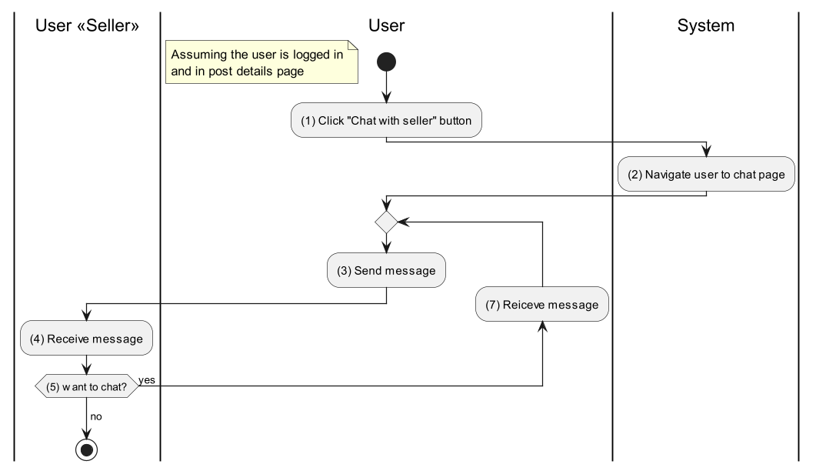

Business Rules
Activity | BR Code | Description
(2) | BR86 | Redirect Rules:  - The system loads the Chat page (refer to “Chat” in the “List description” file).
(3) | BR87 | Sending Rules:  - The system extracts the [sellerId] that the user wants to chat with and [userId] from the request.  - If the socket connection with key [sellerId]-[userId] not exists then [channel] = socket.open()  - The systems extracts [message] from request  - If the [message] contains impolite words then the system shows error message MSG 35.  else [channel].push([message])

UC19: Report post
Name | Report post
Description | This use case describes how users can report violative posts
Actor | Buyer
Trigger | - When the Buyer clicks the ‘Report’ button.
Pre-condition | - The Buyer is logged in to the system.  - The user is on the post details page (refer to “User/Post Details” in the “List description” file).
Post-condition | - The report is created and sent to Admin to review.

Activities Flow
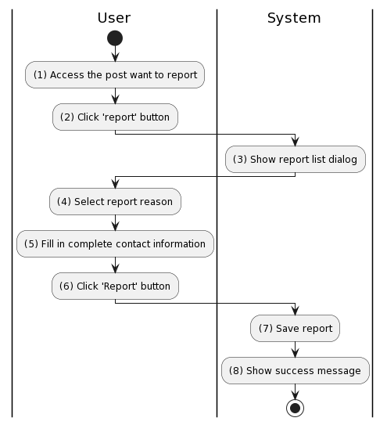

Business Rules
Activity | BR Code | Description
(3) | BR88 | Loading Dialog Rules:  - The system loads the “Report list” dialog.
(4) | BR89 | Report Reason List Rules:  - The system shows the following options:  - Cheat  - Duplicate  - Goods sold  - Unable to contact  - Information is not factually correct  - Counterfeit goods, fake goods  - Goods damaged after purchase
(5) | BR90 | Fill in contact information rules:  - The system request user to provide the following information:  - [report.phone_number]  - [report.email]  - [report.description]
(7) | BR91 | Creating Rules:  When the user clicks the “Report” button, the system will prompt a confirmation message (Refer to MSG 1). If user chooses Cancel, the system does nothing; else, the system will save inputted information and update the item as the following:  - The system check the following items : [report.phone_number], [report.email], [report.reason], [report.description]  - If any entries are empty, the system shows an error message MSG 2.  - If [report.phone_number] is invalid then the system shows message MSG 30  - If [report.email] is invalid then the system shows message MSG 31
(8) | BR92 | Message Rules:  - The system shows message MSG 47

UC20: Create category
Name | Create category
Description | This use case describes how users can create new categories for the system
Actor | Admin
Trigger | - When the Admin clicks the “Create” button.
Pre-condition | - The Admin is logged in to the system.  - The admin accessed the category screen.
Post-condition | - The new category is created.

Activities Flow
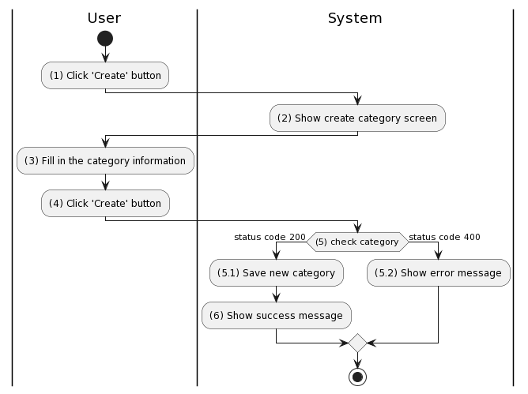

Business Rules
Activity | BR Code | Description
(2) | BR93 | Loading Screen Rules:  - The system loads the “Create category” screen (refer to “Create Category” in the “List description” file).
(3) | BR94 | Fill In Category Rules:  - The system request user to fill in the following information:  - [category.name]  - [category.description]  - [category.brands] = [ {  ‘name’:  ‘logo’:  } ]
(5) | BR95 | Checking Category Rules:  When the user clicks the “Create” button, the system will prompt a confirmation message (Refer to MSG 1). If user chooses Cancel, the system does nothing; else, the system will save inputted information and update the item as the following:  - The system check the following items : [category.name], [category.description],[category.brands]  - If any entries are empty, the system shows an error message MSG 2.  - If [category.name] is already exist then the system return response with status code 400  else the system return response with status code 200
(5.1) | BR96 | Saving Rules:  - The system save the new category with the following entries:  - [category.name]  - [category.description]  - [category.brands] = [{  ‘name’:  ‘logo’:  } ]
(5.2) | BR97 | Message Rules:  - The system shows message MSG 49
(6) | BR98 | Message Rules:  - The system shows message MSG 48

UC21: Update category
Name | Update category
Description | This use case describes how a user can change the category information
Actor | Admin
Trigger | - When the Admin clicks the “Edit” button.
Pre-condition | - The Admin is logged in to the system.  - The admin accessed the category screen.
Post-condition | - The category is updated.

Activities Flow
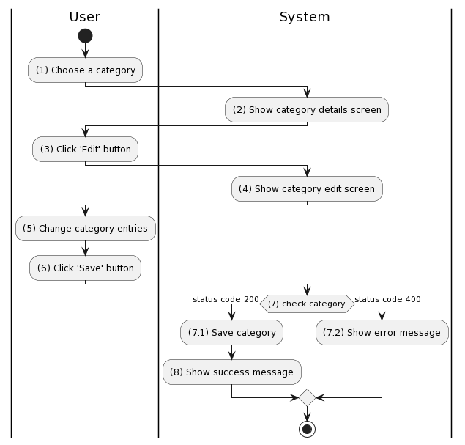

Business Rules
Activity | BR Code | Description
(2) | BR99 | Loading Screen Rules:  - The system loads the “Category details” screen.
(4) | BR100 | Loading Screen Rules:  - The system loads the “Category edit” screen.
(7) | BR101 | Checking Category Rules:  When the user clicks the “Save” button, the system will prompt a confirmation message (Refer to MSG 1). If user chooses Cancel, the system does nothing; else, the system will save inputted information and update the item as the following:  - The system check the following items : [category.name], [category.description],[category.brands]  - If any entries are empty, the system shows an error message MSG 2.  - If [category.name] is already exist then the system return response with status code 400  else the system return response with status code 200
(7.1) | BR102 | Saving Rules:  - The system save the new category with the following entries:  - [category.name]  - [category.description]  - [category.brands] = [{  ‘name’:  ‘logo’:  } ]
(7.2) | BR103 | Message Rules:  - The system shows message MSG 49
(8) | BR104 | Message Rules:  - The system shows message MSG 50

UC22: Delete category
Name | Report post
Description | This use case describes how a user can delete a category
Actor | Admin
Trigger | - When the Admin clicks the “Delete” button.
Pre-condition | - The Admin is logged in to the system.  - The Admin accessed the category screen.
Post-condition | - The categories are deleted.

Activities Flow
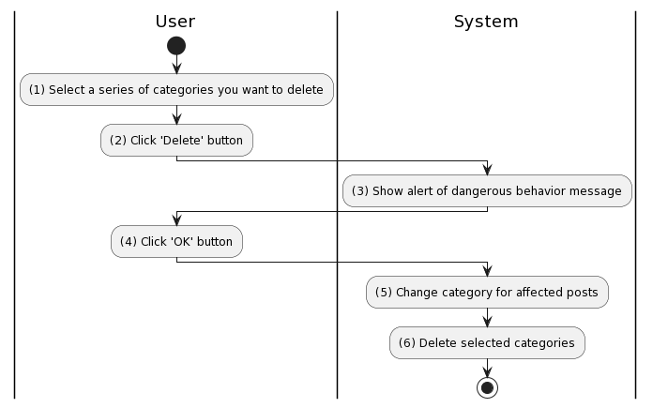

Business Rules
Activity | BR Code | Description
(3) | BR105 | Loading Screen Rules:  - The system shows message MSG 51
(5) | BR106 | Changing Rules:  For each selected categories:  - [postRepository].findAllByCategory([selectedCategory])  - for each post found: [post.category] = [categoryRepository].findByName(‘other’)
(6) | BR107 | Deleting Rules:  For each selected categories:  - If ( [categoryRepository].existById([selectedCategory.id]) == true ) then [categoryRepository].deleteById([selectedCategory])  else the system returns a response with status code 400 and shows message MSG 49

UC23: Approve post
Name | Approve post
Description | This use case allows the Administrator to approve the user's post.
Actor | Administrator
Trigger | - When the Administrator clicks on the “Approve” button.
Pre-condition | - The Administrator is logged in to the system with ‘Admin’ permission.
Post-condition | - The post is approved and visible to all users.

Activities Flow
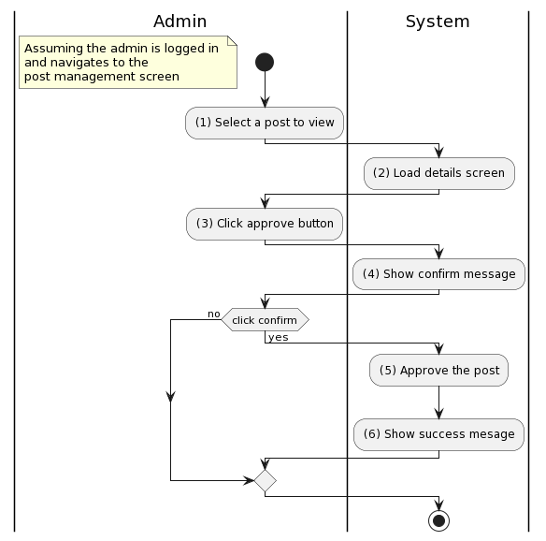

Business Rules
Activity | BR Code | Description
(2) | BR108 | Loading Screen Rules:  - The system loads the “Post details” screen (refer to “Admin/Post Details” in the “List description” file).
(4) | BR109 | Message Rules:  - The system shows message MSG 7
(5) | BR110 | Approving rules:  - If the current user is not ADMIN then the system shows error message MSG 15.  - The system will update the item as the following:  - [status] = APPROVED
(6) | BR111 | Message Rules:  - The system shows message MSG 8

UC24: Reject post
Name | Reject post
Description | This use case allows the Administrator to reject the user's post.
Actor | Administrator
Trigger | - When the Administrator clicks on the “Reject” button.
Pre-condition | - The Administrator is logged in to the system with ‘Admin’ permission.
Post-condition | - The post is rejected and deleted.

Activities Flow
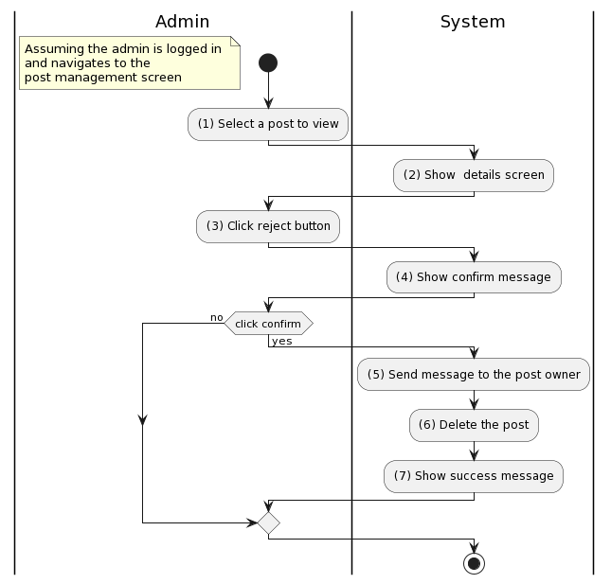
Figure 1: Activities Flow

Business Rules
Activity | BR Code | Description
(2) | BR112 | Loading Screen Rules:  - The system loads the “Post details” screen (refer to “Admin/Post Details” in the “List description” file).
(4) | BR113 | Message Rules:  - The system shows message MSG 9
(5) | BR114 | Notification Rules:  - The system sends a notification to the seller's dialog box according to the following template:  - ‘Your post with the title’+ [Name] + ‘has been approved by the Administrator. \nNow everyone can see your posts.’
(7) | BR115 | Message Rules:  - The system shows message MSG 10

UC25: Ban account
Name | Ban account
Description | This use case describes how a user can ban a user account that violates website’s regulations
Actor | Admin
Trigger | - When the Admin clicks the “Ban” button.
Pre-condition | - The Admin is logged in to the system.  - The Admin accessed the user screen.  - The user account has been reported in violation.
Post-condition | - The user account is banned.

Activities Flow
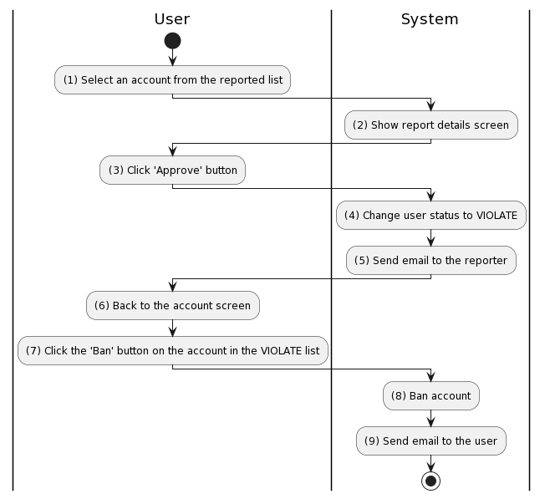

Business Rules
Activity | BR Code | Description
(2) | BR116 | Loading Screen Rules:  - The system loads the “Report details” screen
(4) | BR117 | Changing Rules:  - [user.status] = VIOLATE
(5) | BR118 | Sending email rules:  - Email Templates:  - Send mail to user after approve their report:  From techmarket@gmail.com  To [user.email]  Cc N/A  Subject Get [Subject] of “Email Template” item of which [Keyword] = “Your report has been approved”  Body Get [Body] of “Email Template” item of which [Keyword] = “Your report has been approved”  - Following is a sample email content:  Subject "Your report has been approved - Tech Market"  Body [Body] = “Hello,” [Body] = [Body] + 2 new lines [Body] = [Body] + “Thanks for your report on the post [post.title]!” [Body] = [Body] + 2 new lines [Body] = [Body] + “We have reviewed and confirmed the user [user.username] violated our rules. Posts by this person will be taken down.” [Body] = [Body] + 2 new lines [Body] = [Body] + "Thank you for your cooperation. Hope you continue to accompany us.” [Body] = [Body] + 2 new lines [Body] = [Body] + "Best regards," [Body] = [Body] + 2 new lines [Body] = [Body] + "The Tech Market team"
(8) | BR119 | Ban Rules:  - [user.status] = BANNED
(9) | BR120 | Sending email rules:  - Email Templates:  - Send mail to user after change their account status:  From techmarket@gmail.com  To [user.email]  Cc N/A  Subject Get [Subject] of “Email Template” item of which [Keyword] = “Account violates regulations”  Body Get [Body] of “Email Template” item of which [Keyword] = “Account violates regulations”  - Following is a sample email content:  Subject "Account violates regulations - Tech Market"  Body [Body] = “Hello,” [Body] = [Body] + 2 new lines [Body] = [Body] + “We found that your account violates our posting rules.” [Body] = [Body] + 2 new lines [Body] = [Body] + “Report Details:” [Body] = [Body] + 1 new lines [Body] = [Body] + “- Reason: [report.reason]” [Body] = [Body] + “- Details: [report.description]” [Body] = [Body] + "If you have any questions or concerns, please feel free to contact our customer support." [Body] = [Body] + 2 new lines [Body] = [Body] + "Thank you for using our service!" [Body] = [Body] + 2 new lines [Body] = [Body] + "Best regards," [Body] = [Body] + 2 new lines [Body] = [Body] + "The Tech Market team"

UC26: Manage TechMarket bank account
Name | Manage TechMarket bank account
Description | This use case describes how a user can manage a client's trading currency storage account.
Actor | Admin
Trigger | - When the Admin wants to change TechMarket bank account.
Pre-condition | - The Admin is logged in to the system.  - The Admin accessed the bank account screen.
Post-condition | - The bank account is changed.

Activities Flow
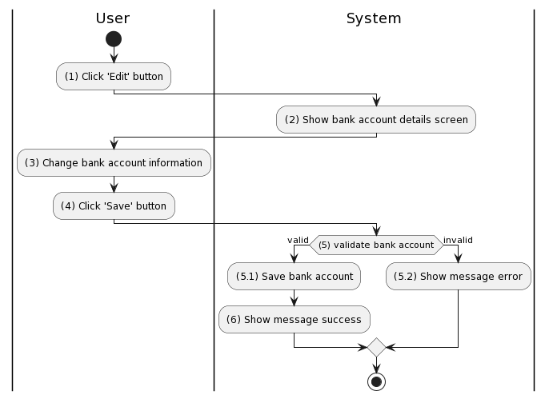

Business Rules
Activity | BR Code | Description
(2) | BR121 | Loading Screen Rules:  - The system loads the “Bank account details” screen
(3) | BR122 | Bank Rules:  - Change the following entries:  - [Bank] - select in a bank list  - [Account_number]
(5) | BR123 | Validating rules:  - Verify account information with the selected bank.
(5.1) | BR124 | Saving Rules:  - [bankAccount] = {  ‘bank’ : <<selected bank>>,  ‘account_number’: <<entered number>>  }
(5.2) | BR125 | Message Rules:  - The system shows message MSG 53
(6) | BR126 | Message Rules:  - The system shows message MSG 52

UC27: Update legal documents
Name | Update legal documents
Description | This use case describes how users can update legal documents related to a publicly available website.
Actor | Admin
Trigger | - When the Admin wants to change legal documents.
Pre-condition | - The Admin is logged in to the system.  - The Admin accessed the legal document screen.
Post-condition | - The documents are changed.

Activities Flow
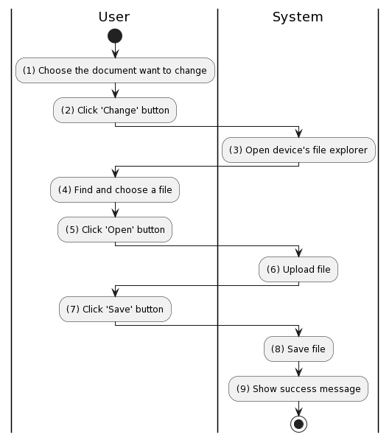

Business Rules
Activity | BR Code | Description
(3) | BR127 | Opening File Rules:  - Require the following file types: .doc, .docx, .pdf.
(8) | BR128 | Saving Rules:  - Replace document with the file you just uploaded.
(9) | BR129 | Message Rules:  - The system shows message MSG 54

UC28: Update information for the help center
Name | Update information for the help center
Description | This use case describes how users can update content and questions for the help center.
Actor | Customer Care Department
Trigger | - When the Customer Care Department wants to update the help center.
Pre-condition | - The Customer Care Department is logged in to the system.  - The Customer Care Department accessed the document screen.
Post-condition | - The documents are changed.

Activities Flow
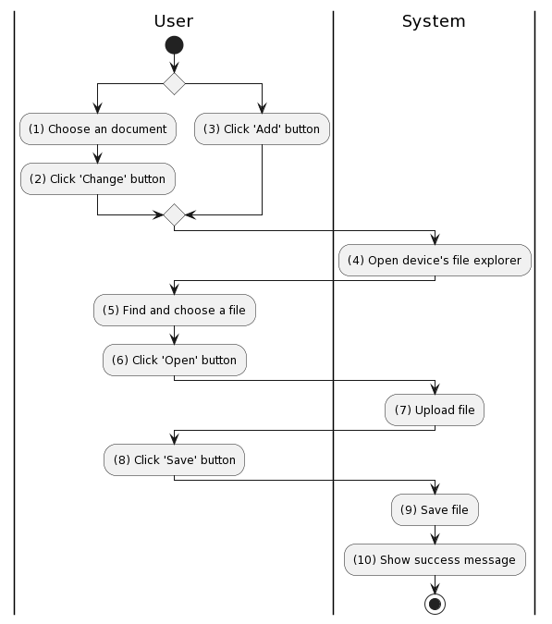

Business Rules
Activity | BR Code | Description
(4) | BR130 | Opening File Rules:  - Require the following file types: .doc, .docx, .pdf.
(9) | BR131 | Saving Rules:  - If the user makes a change then replace the document with the file you just uploaded.  - If the user makes an addition then the file you just uploaded will be saved.
(10) | BR132 | Message Rules:  - The system shows message MSG 54

UC29: Handle feedback from user
Name | Handle feedback from user
Description | This use case describes how users can view and respond to customer feedback.
Actor | Customer Care Department
Trigger | - When the Customer Care Department wants to handle user feedback.
Pre-condition | - The Customer Care Department is logged in to the system.  - The Customer Care Department accessed the feedback screen.
Post-condition | - The feedback is handled.

Activities Flow
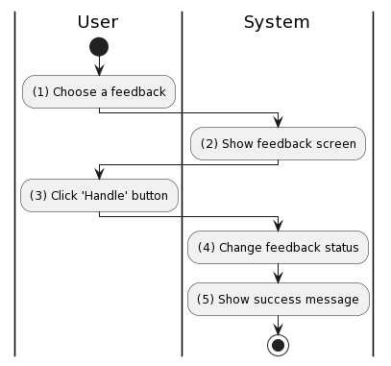

Business Rules
Activity | BR Code | Description
(2) | BR133 | Loading Screen Rules:  - The system shows the “Feedback details” screen.
(3) | BR134 | Handling Rules:  - Users need to carefully consider feedback before clicking the ‘Handle’ button
(4) | BR135 | Changing Rules:  - [feedback.status] = HANDLED
(5) | BR136 | Message Rules:  - The system shows message MSG 55

List Description
TechMarket List Description.xlsx

View Description
TechMarket List View.xlsx

Non-functional Requirements

3.1. User Access and Security
Actor  Function | Admin | User | Buyer | Seller | Customer Care Department
Sign In | x | x
Sign Up |  | x
Forgot password |  | x
Leave a feedback |  | x | x
Create post |  | x
Update post |  | x
Delete post |  | x
Guarantee payment |  |  |  | x
Link sales wallet |  |  |  | x
Use post push service |  |  |  | x
Confirm sales order |  |  |  | x
Place order |  |  | x
Choose shipping address |  |  | x
Pay |  |  | x
Cancel order |  |  | x
Confirm delivery of order |  |  | x
Rate seller |  |  | x
Chat with seller |  |  | x
Report post |  |  | x
Create category | x
Update category name | x
Delete category | x
Approve post | x
Reject post | x
Ban account | x
Manage TechMarket bank account | x
Update legal documents | x
Update information for the help centre |  |  |  |  | x
Handle feedback from user |  |  |  |  | x

X: User has full permission to do the action.

3.2. Performance Requirements
Number of user
- Number of concurrent user: 150
- Number of business user: 600 - 700

Data volume
- Number of documents: 6M – 8M file size
- Data growth rate: 5MB/ day

Level of availability
- 95%: Effective system management (assessed according to IBM standards, continuous operating time per year is no more than 18.25 days).

Usage frequency
- The system is used regularly, every hour there will be data exchanged between businesses and their supply partners. Therefore, the system needs to be set up on a server capable of operating throughout business hours. Upgrades, maintenance, and repairs only take place after hours.

3.3. Implementation Requirements
Location
Ho Chi Minh city
Read-only Duration
1 day
Read-only Timeframe
0:00
Maintenance Window
Every week on Sunday evening at 11 p.m., lasting 1 to 2 hours. During this time, programmers can take advantage of it to edit and update new code
Overall conversion timeline
1st, 15th and 25th of every month

Appendixes

Glossary
The list below contains all the necessary terms to interpret the document, including acronyms and abbreviations.
Term | Description
BR | Business Rule
CBR | Common Business Rule
DB | Notes Database
MSG | Message
UC | Use Case
N/A | Not Available or Not Applicable, used to indicate when information in a certain section could not be provided because it does not apply to this application.
UI | User Interface
SRS | Software Requirements Specification
TBD | To be determined or to be defined

Messages
This section describes the details of messages used in business rules e.g. error messages, confirmation messages, etc.

Message Code | Message Content | Button
MSG 1 | Are you certain with this decision? | OK/Cancel
MSG 2 | You need to fill in all fields
MSG 3 | Your post is ready to publish. Waiting for the Administrator.
MSG 4 | Payment failed. Please check your account.
MSG 5 | Payment success.
MSG 6 | Are you sure you have received your order? | OK/Cancel
MSG 7 | Are you certain to approve this post?
MSG 8 | Approve successful
MSG 9 | Are you certain to reject this post?
MSG 10 | Reject successful
MSG 11 | File size is too large
MSG 12 | Product does not exist
MSG 13 | Price can not be less than 0
MSG 14 | Description must contain at least 50 characters
MSG 15 | You don’t have permission
MSG 16 | Your post has been updated. Waiting for the administrator's approval.
MSG 17 | Update post failed.
MSG 18 | The post does not exist.
MSG 19 | Can not delete the post that has been purchased.
MSG 20 | Delete post successfully.
MSG 21 | Delete post failed.
MSG 22 | Username or password is incorrect.
MSG 23 | Logged in successfully.
MSG 24 | Username must contain at least 8 characters.
MSG 25 | Invalid password
MSG 26 | Phone number has been used.
MSG 27 | Email has been used.
MSG 28 | Successfully registered.
MSG 29 | Phone/email already exists.
MSG 30 | Invalid phone number.
MSG 31 | Invalid email
MSG 32 | User not found.
MSG 33 | Invalid verification link.
MSG 34 | Must not be the same as the old password
MSG 35 | The post does not exist.
MSG 36 | The message contains impolite words.
MSG 37 | Invalid payment information.
MSG 38 | Payment success.
MSG 39 | Payment failed.
MSG 40 | Confirm order successfully.
MSG 41 | Rating buyer failed.
MSG 42 | Thanks for your rating.
MSG 43 | This post has been updated with 'Guarantee Payment'
MSG 44 | You need to link to your sales wallet first! | Link/Cancel
MSG 45 | Phone number is not valid
MSG 46 | OTP is incorrect
MSG 47 | Thank you for your report. We will review and send the verification results to the email you provide.
MSG 48 | Your new category has been created.
MSG 49 | The category name already exists
MSG 50 | Category update successful
MSG 51 | ALERT. Do you want to delete these categories? This action can not be undone. | OK/Cancel
MSG 52 | Account change successful
MSG 53 | This account is Invalid.
MSG 54 | Document was updated successfully.
MSG 55 | Handle feedback successful

Issues List
N/A

